

**ALAGAPPA COLLEGE OF TECHNOLOGY**

**ANNA UNIVERSITY-600025**

**NM Assignment / Digital Marketing**

| NAME | REG.NO | Naan Mudhalvan ID |
| --- | --- | --- |
| Durga devi. S | 2020308008 | 5D33032F9C8693EB58D4064DD8983D14 |

**1. Create a blog or website using Blogpost Customize the theme design and post new article with 500 words.**

https://www.blogger.com/blog/post/edit/2881967399118009003/3853161651947481819

2. Create a New Facebook Business Page and post one social media poster for your brand.

**https://www.facebook.com/profile.php?id=61550921162078&mibextid=ZbWKwL**

3. design a social media advertisement poster using canva.

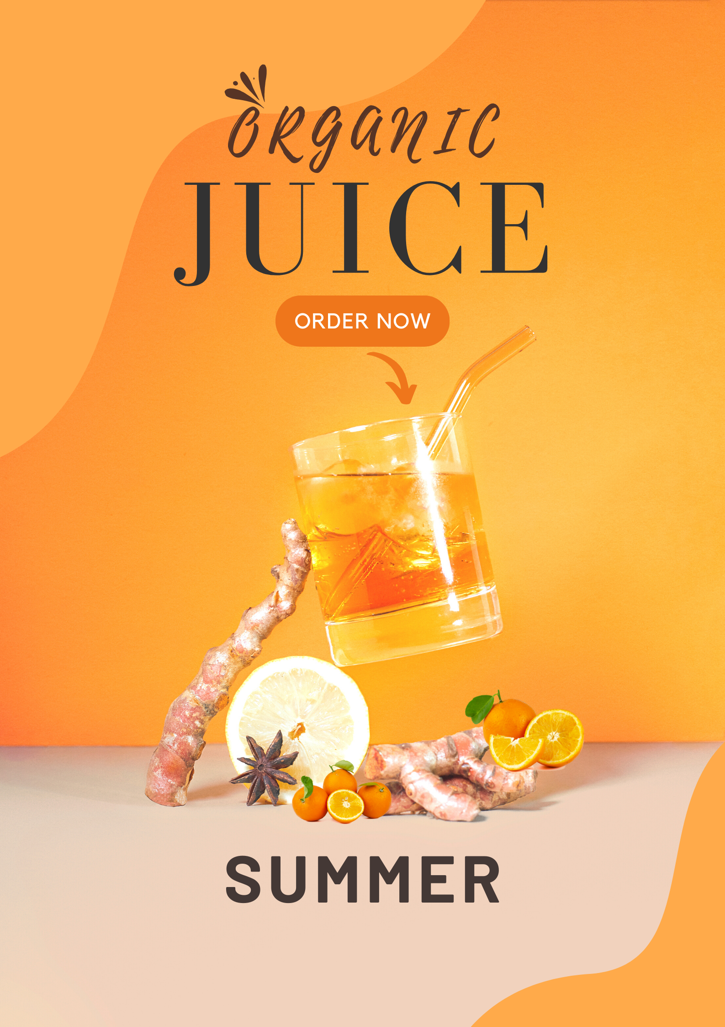

4. Create email newsletter design using MailChimp or canva tool.

